Technical Seminar and Examination for Instructors and Dan-grading Examination for Overseas Members

Dear Sir or Madam,

We wish you all the best in your health.
Please inform all relevant members in your area of ​​the above information. Also, please have those members fill out an application form and submit it to the Wado-Kai Headquarters. Members who are aiming to obtain instructor qualifications can take the course for a fee.

- Seminar/Examinations
1) Date: Friday, January 31 - Sunday, February 2, 2025
2) Seminar Venue
The venues for January 31 and February 1-2 are different. Please be careful not to make a mistake.
- January 31st (Friday)
BumB Tokyo Culture and Sports Center (hereafter referred to as BumB, see Attachment 1)
2-1-3 Yumenoshima, Koto-ku, Tokyo 136-0081 Tel: 03-3521-7321
Access:
- 10 minutes’ walk from Shinkiba station (JR Keiyo Line, Rinkai Line, Tokyo Metro Yurakucho Line)
- 5 minutes’ walk from Toei Bus "Yumenoshima" bus stop
- February 1st (Saturday) - February 2nd (Sunday)
Toshima Ward Minami-nagasaki Sports Center (hereafter referred to as Minami-nagasaki SC, see Attachment 2)
4-13-5 Minami-nagasaki Toshima-ku, Tokyo 171-0052 Tel: 03-5988-9270
Access:
- 2 minutes’ walk from exit A2 Ochiai Minami-nagasaki station, Oedo Line
- 10 minutes’ walk from the south exit of Higashi-nagasaki station, Seibu Ikebukuro Line
3) Seminar
- January 31st (Friday) BumB
Registration 9:15~ (entrance 9am)
Seminar 9:45~16:30
- February 1st (Saturday) Minami-nagasaki SC
Registration 9:15~ (entrance 9am)
Seminar 9:30~16:00
4) Examination
- Saturday, February 1st Minami-nagasaki SC
Dan examination 17:00-19:00
* Examination time will be changed depending on the number of examinees.
- Sunday, February 2nd Minami-nagasaki SC
Registration 9:30-11:00
Instructor examination 11:00-18:00
*Examination time will be changed depending on the number of examinees.

- Technical Seminar Lecturers
Shimura Koichi, Technical Committee Chair, and other 1st grade instructors

- Technical Seminar Contents
Kihon (basics), Kihon-Kumite and Kata

- Examination Contents
- Dan Examination for Overseas Members (3rd to 5th Dan)
a. Kihon: From Jun-Tsuki to Tobikomi-Nagashi-Tsuki and Keri (kick)
b. Kihon-Kumite: Two Kihon-Kumite, out of No 1 to No. 10, specified on the day
c. Kata: Two Kata in total (either Seishan or Chinto must be specified on the day, and the other Kata must be selected from the list below, excluding Pin-an and Shitei-Kata).
*Kushanku, Naihanchi, Bassai, Niseishi, Wanshu, Jitte, Jion, Rohai. And Seishan or Chinto which was not specified on the day
d. Jiyu-Kumite: Free sparring
- Instructor Examination
a. Kihon: From Jun-tsuki to Tobikomi-nagashi-tsuki and Keri (kick)
b. Kihon-Kumite: Ippon-me (No. 1) is mandatory for all the examinees. And five odd or even numbers Kihon-Kumite from No 1 to No. 10, specified on the day.
c. Kata: Three Kata in total (first Seishan, second Chinto, and lastly Kata selected from the list below).
Kushanku, Naihanchi, Bassai, Niseishi, Wanshu, Jitte, Jion, Rohai
d. Jiyu- Kumite: Free sparring
Sparring gloves and mouthguard are required.

- Fee:
The following fee are to be paid at the reception desk on the day of seminar/examination
  - Technical Seminar fee
    - For 2 days (January 31st and February 1st) 10,000 JPY
    - For 1 day (January 31st or February 1st) 5,000 JPY
  - Dan examination Fee
＊3rd to 5th Dan Examination 5,000 JPY
3) Instructor Examination Fee
＊1st～3rd Class 5,000 JPY
4) Registration Fee
Those who pass the Dan-grading examination (the results will be announced the next day) must pay the registration fee (in cash) shown in the table below at the reception desk. If the fee is not paid, the certification of Dan will be cancelled.

Table 1. Dan-grading Examination/Registration
Dan-grade | Examinee’s prerequisite | Fee to register
 | (Practical Dan-grade)
3rd Dan | 2nd Dan holder | 10,000 JPY
4th Dan | 3rd Dan holder | 15,000 JPY
5th Dan | 4th Dan holder | 25,000 JPY

Those who pass the instructor examination (the results will be announced on the day) must pay the registration fee shown in the table below by the separately specified method. If the fee is not paid, the qualification will not be certified.

Table 2. Instructor Examination/Registration
Class to | Examinee's prerequisite | Fee to Register
register | (Practical Dan-grade)
3rd class | 3rd Dan or higher (Aged 25or Elder) | 10,000 JPY
2nd class | 4th Dan or higher (Aged30 or Elder) | 10,000 JPY
1st class | 6th Dan or higher (Aged45 or Elder) | 20,000 JPY
Those who hold the practical 6th Dan can take the 2nd grade instructor exam.

How to apply for each examination
Please fill in the attached application form and send it to the Wadokai Headquarters.

Where to apply for the technical seminar
JKF Wado-Kai Headquarters Uematsu Bldg. 7F,
1-9-2, Nishi-shimbashi, Minato-Ku, Tokyo 105-0003, Japan
Application deadline: Friday, January 17, 2025 completed application forms must arrive at the Wado-Kai Headquarters by his date.
*1 Anyone who is a member of Wado-kai and above Sho-Dan (1st Dan), and who aims to become an instructor in the future or is interested in the instructor seminar, can participate in the seminar regardless of their qualifications or Dan.
*2 Please prepare your own lunch on the day.

Attachment 1 BumB Tokyo Culture and Sports Center

2-1-3 Yumenoshima, Koto-ku, Tokyo 136-0081 Tel: 03-3521-7321
Access
- 10 minutes’ walk from Shinkiba station (JR Keiyo Line, Rinkai Line, Tokyo Metro Yurakucho Line)
- 5 minutes’ walk from Toei Bus "Yumenoshima" bus stop
BumB Tokyo Culture and Sports Center

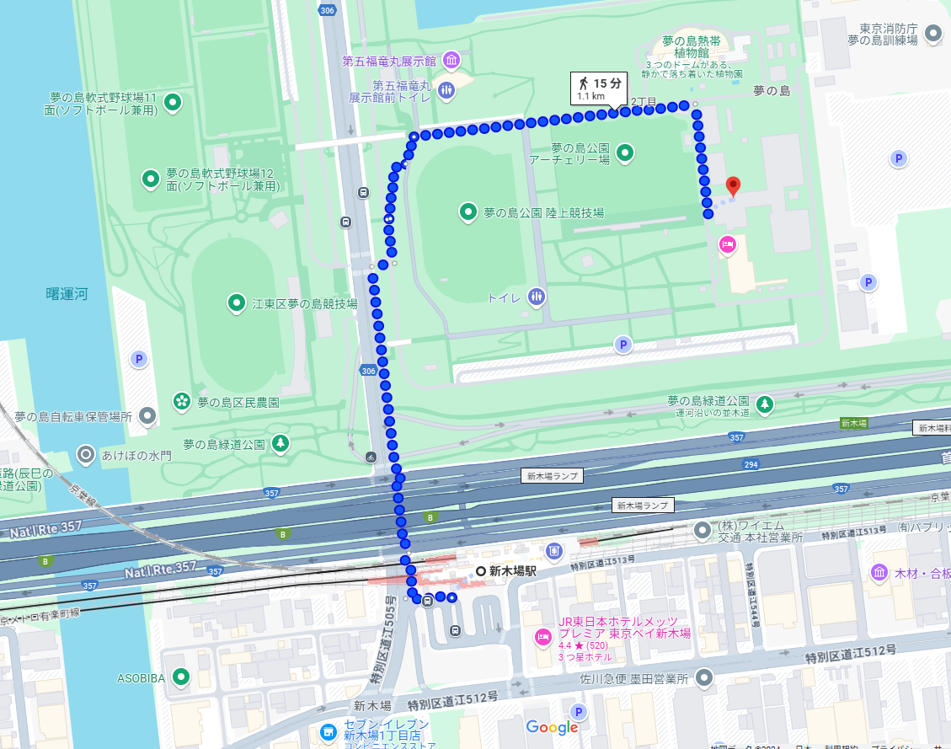
Shinkiba station
Attachment 2 Minami-nagasaki SC

4-13-5 Minami-nagasaki Toshima-ku, Tokyo 171-0052 Tel: 03-5988-9270
Access
- 2 minutes’ walk from exit A2 Ochiai Minami-nagasaki station, Oedo Line
- 10 minutes’ walk from the south exit of Higashi-nagasaki station, Seibu Ikebukuro Line
Higashi-nagasaki station

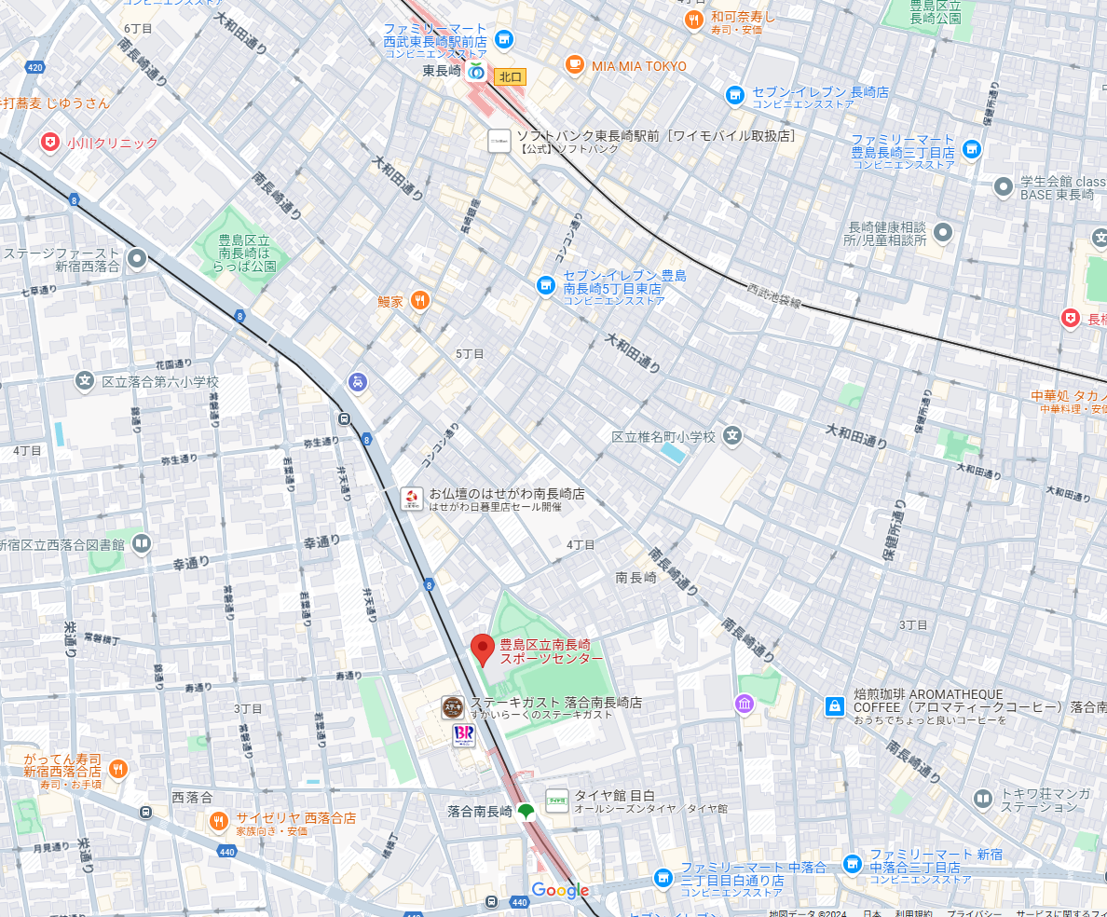
Minami-nagasaki station
Minami-nagasaki SC

